**SEPTEMBER 2023**

Palm Bay Academy

8 oz of Milk is served with Breakfast and Lunch

Lactose free is available upon request

If your child will be late, please inform the cafeteria. By 8:30 am at elementary. By 9:30 am at middle school.

Corn Dogs

Sweet Potato Fries, Carrots/ Ranch

Peaches

Chicken Salad,

WG Pita Bread

carrots

Chips, Pineapple

Salisbury Steak W/Gravy

Hashbrown Casserole, WG Dinner roll, Broccoli

Peaches

Pizza

Carrots, Broccoli/ Ranch

Seasonal Fruit

Chicken Fajita,

Mexican Rice, Beans

Lettuce, tomatoes, cheese, salsa

Pineapple

Nuggets/Fries

Corn in the cob

Dinner roll

Mixed Fruits

Hot Dogs,

French Fries

Corn On the cob

Apple Sauce

Meatloaf/Gravy

W/ Mashed Potato, dinner roll

Green Bean Casserole

Apple

Spaghetti and Meatballs

Garlic Knots, Peas

Pineapple

Quesadilla

Mexican Rice, Frijoles

Tropical Fruit

Turkey & Cheese Sandwich

½ cup Carrots/ Celery 4oz of Hummus

Apple

Yellow rice w/

Pigeon Peas,

baked chicken

Chef Salad

Seasonal Fruits

Mozzarella Stick/

Marinara Sauce

Celery/Carrots w/ ranch

Pineapples

Burritos

Cowboy Salad (Mexicorn & Blackbeans)

Banana

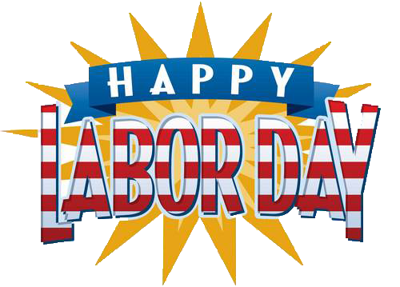

Yogurt, Cheese

stick,

WG Crackers, ¾ cup Celery Hummus

Orange

Haystacks (Ground meat, Refried Beans, Chips)

Lettuce, tomatoes, cheese, salsa

Seasonal Fruit

Baked Ziti W/Beef crumbles

Garlic sticks, Collard Greens

Mandarin oranges

Orange Chicken

W/Rice

Oriental Vegetables

Orange

Chicken Sandwich, Fries, Coleslaw & Pickle

Pears cup

Boneless Wings

Fries

Dinner roll

Celery sticks, Carrots, Ranch Dressing

Tropical Fruit